Status of This Document

  - Version History
Ver. No. | Date | Revised By | Description | Filename
0.1 | 29 May 2007 | Twinsen Tsang | Style updated for new H2O Release From old document. | Hermes 2 Administration Tool User Guide.doc
0.2 | 26 Aug 2008 | Jumbo Cheung | Added paragraphs to explain the “retry” button. | Hermes 2 Administration Tool User Guide.doc

Table of Contents
1. Status of This Document 2
1.1. Version History 2
2. Table of Contents 3
3. Figures 4
4. Introduction 5
4.1. Purpose of This Document 5
4.2. Intended Audience 5
4.3. Scope of the Document 5
4.4. Prerequisite 5
5. Getting Started 7
5.1. User Login 7
5.2. Main Screen 7
5.3. Corvus Main System Administration 9
5.3.1. HTTP Dispatcher 9
5.3.2. Plugin Registry 11
5.3.3. Module Information 11
5.3.4. Core Properties 12
5.3.5. JVM Properties 14
5.4. ebXML Messaging Services Plugin Administration 15
5.4.1. Message History 15
5.4.2. Partnership 21
5.5. AS2 Plugin Administration 26
5.5.1. Message History 26
5.5.2. Partnership 30
6. References 36

Figures
Figure 1. Login window 7
Figure 2. The main screen of Hermes 2 administration console 8
Figure 3. Confirmation window to run garbage collection 9
Figure 4. Confirmation window to run finalization 9
Figure 5. The screen showing all HTTP dispatchers of the Hermes 2 system 10
Figure 6. Confirmation window to halt the Hermes 2 dispatcher 10
Figure 7. The screen showing all the plugins currently deployed at the Hermes 2 system 11
Figure 8. The screen showing summary of module group and dependencies in the Hermes 2 system 12
Figure 9. The screen for showing and editing the core property values of Hermes 2 system 13
Figure 10. Confirmation window for updating the core property values of Hermes 2 system 14
Figure 11. The screen for showing and editing the JVM property values of Hermes 2 system 14
Figure 12. Confirmation window for updating the JVM property values of Hermes 2 system 15
Figure 13. The screen for querying the message status 16
Figure 14. The screen showing the query result of message status 17
Figure 15. The screen showing the acknowledgment of a particular message 18
Figure 16. The screen for downloading the message body 19
Figure 17. The screen for managing the partnership information 21
Figure 18. The screen for editing existing partnership information 22
Figure 19. Confirmation window to update the partnership 22
Figure 20. The screen showing the system message when there is wrong information input when editing partnership information 23
Figure 21. Confirmation window to delete the partnership 23
Figure 22. The screen for adding new partnership information 24
Figure 23. Confirmation window to add the partnership 24
Figure 24. The screen showing the system message when there is wrong information input when adding partnership information 25
Figure 25. The screen for querying the message status 26
Figure 26. The screen showing the query result of message status 27
Figure 27. The screen showing the acknowledgment of a particular message 28
Figure 28. The screen for downloading the message body 29
Figure 29. The screen for managing the partnership information 31
Figure 30. The screen for editing existing partnership information 32
Figure 31. Confirmation window to update the partnership 32
Figure 32. The screen showing the system message when there is wrong information input when editing partnership information 33
Figure 33. Confirmation window to delete the partnership 34
Figure 34. The screen for adding new partnership information 34
Figure 35. Confirmation window to add the partnership 35
Figure 36. The screen showing the system message when there is wrong information input when adding partnership information 35

Introduction
Hermes 2 is a multi-protocol B2B messaging system. Its extensible architecture allows different B2B messaging protocols to be supported through deployment of different plugins.

  - Purpose of This Document
The purpose of this document is to describe the steps for configuring Hermes 2 using its administration console.
In this release, Hermes 2 supports two protocols – AS2 and ebXML Messaging Service. Since Hermes 2 implements a flexible plugin mechanism to support different B2B messaging protocols, there are two main kinds of configuration tasks described in this document.
First, this document will cover the configuration steps to manage plugins. Second, this document will cover the configuration steps to manage the administrative parameters of each of the two protocols supported.

  - Intended Audience
The intended audience of this document includes the operators who handle the configuration and routine maintenance of the Hermes 2 system. Also, the application developers will find this document useful to configure their Hermes 2 system for development of B2B applications.

  - Scope of the Document
The scope of this document includes the following:
- configuration steps to manage plugins and the Java Runtime Environment (JRE)
- configuration steps to manage the AS2 sub system and the related B2B partnership information
- configuration steps to manage the ebXML Messaging Service sub system and the related B2B partnership information

  - Prerequisite
The users should have the Hermes 2 system installed successfully. The steps for installing the system can be found at the Hermes 2 GPL Edition Installation Guide.
The users should use a web browser to access the Hermes 2 administration console.

Getting Started
  - User Login
The Hermes 2 administration console is a Web based system. The user can access the administration console using a web browser. Typically the URL of the administration console is:
http://<installation server host>:<installation port>/corvus/admin/home
The Hermes 2 administration console employs container managed authentication to make sure only authorized users can access the console. It requires an authenticated user with the role "admin" to access. By default, Tomcat stores the user and role information at the "CATALINA_BASE/conf/tomcat-users.xml" file.

When the URL of the administration console is accessed, the browser will prompt up a window (Figure 1) for the user to enter his user name and password.

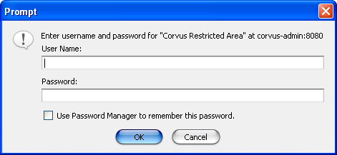
- Login window

Main Screen
After authentication, the browser will be loaded with the main screen of the administration console (Figure 2).

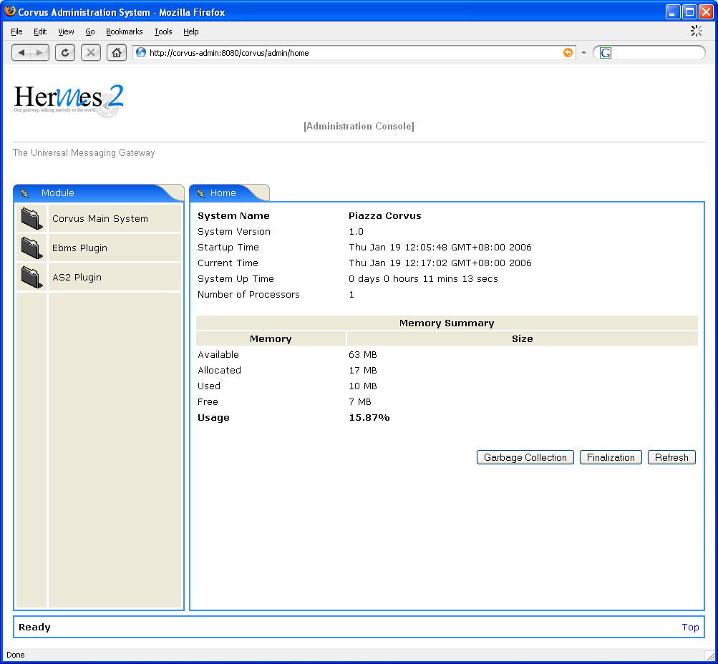
- The main screen of Hermes 2 administration console

A Hermes 2 logo will be shown on the top-left corner of every page of the administration console. It is linked to the main screen of the console.
The main screen shows the brief information about the running Hermes 2 system. It shows the version number, the system startup time of the running system. It also shows the memory summary of the system.
From the main screen, the user can trigger the Java Runtime Environment to perform garbage collection. Upon clicking on the “Garbage Collection” button, a window (Figure 3) will be shown to prompt the user for confirmation.

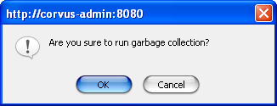
- Confirmation window to run garbage collection

The user can also trigger the object finalization in the Java Runtime Environment. Upon clicking on the “Finalization” button, a window (Figure 4) will be shown to prompt the user for confirmation.

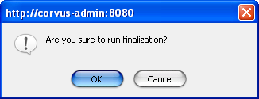

- Confirmation window to run finalization

Corvus Main System Administration
The Corvus main system handles the plugins in the running system. It also manages the runtime property values of the Hermes 2 system as well as the Java Runtime Environment.
When the user clicks on the link of Corvus Main System in the menu at left hand side, the administration console will show the pages inside the Corvus Main System in the content area at the right hand side.
There are five administration pages in the Corvus Main System.

HTTP Dispatcher
There are five administration pages in the Corvus Main System, the first one will be shown by default. It is the page showing all the HTTP dispatcher currently configured in the Hermes 2 running system (Figure 5Error: Reference source not found).
This is a summary page which displays the current status, the number of current active threads, etc. information. The users can also find the listing of all request listeners currently deployed.

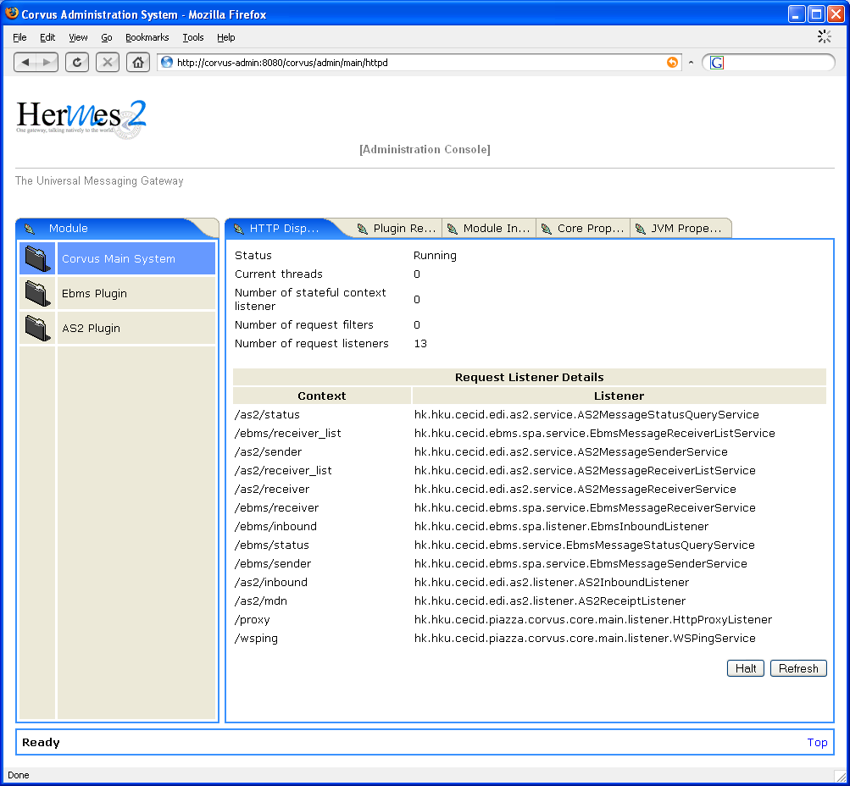

- The screen showing all HTTP dispatchers of the Hermes 2 system
From this page, the user can click on the "Halt" button to bring down the HTTP handler of Hermes 2 system. Upon clicking the button, a window (Figure 6) will be shown to prompt the user for confirmation.

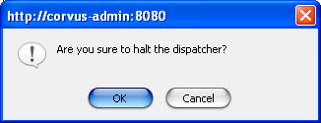
- Confirmation window to halt the Hermes 2 dispatcher
The user can also click on the "Refresh" button to refresh the information shown.

Plugin Registry
When the user clicks on the tab "Plugin Re…" at the top part of the content area at the right hand side, the screen displaying all the plugins currently deployed at the Hermes 2 system and their relevant information, will be shown (Figure 7).

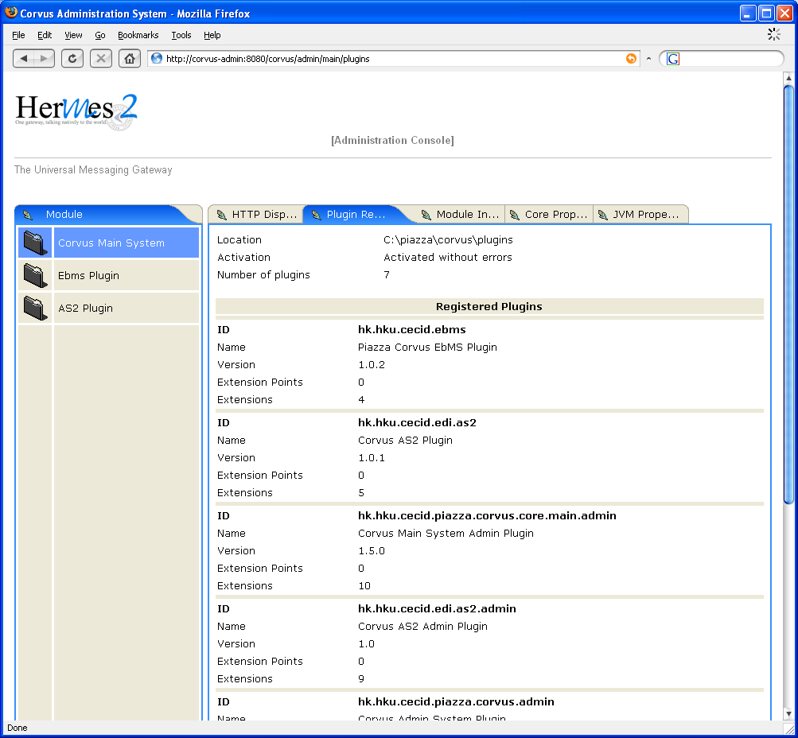

- The screen showing all the plugins currently deployed at the Hermes 2 system

Module Information
When the user clicks on the tab "Module In…" at the top part of the content area at the right hand side, the screen displaying the module group information will be shown (Figure 8).

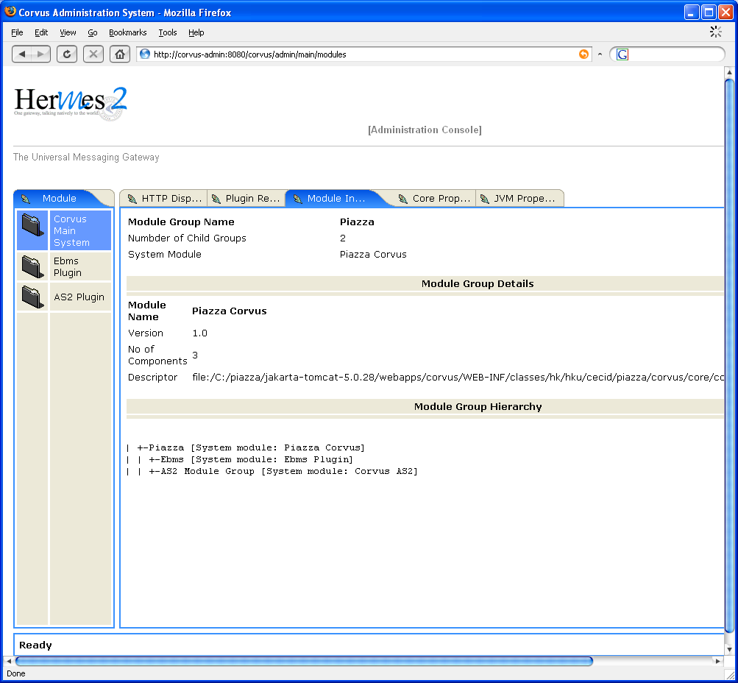

- The screen showing summary of module group and dependencies in the Hermes 2 system

Core Properties
When the user clicks on the tab "Core Prop…" at the top part of the content area at the right hand side, the screen for editing the core system properties will be shown (Figure 9).

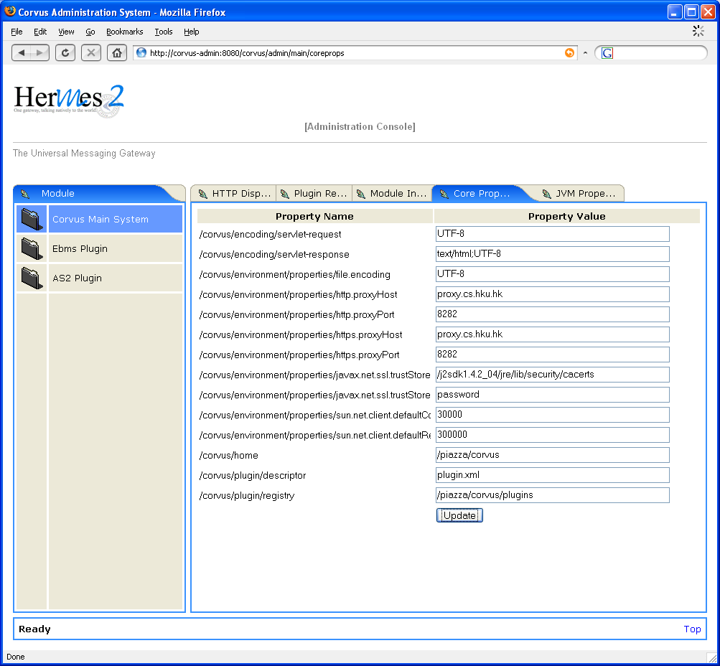

- The screen for showing and editing the core property values of Hermes 2 system

The user can enter new property values in the text boxes of the page. To commit the change, the users can click on the "Update" button. Upon clicking, a window (Figure 10) will be shown to prompt the users for confirmation.

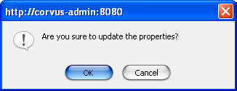

- Confirmation window for updating the core property values of Hermes 2 system

JVM Properties
When the user clicks on the tab "JVM Prope…" at the top part of the content area at the right hand side, the screen for editing the JVM properties will be shown (Figure 11).

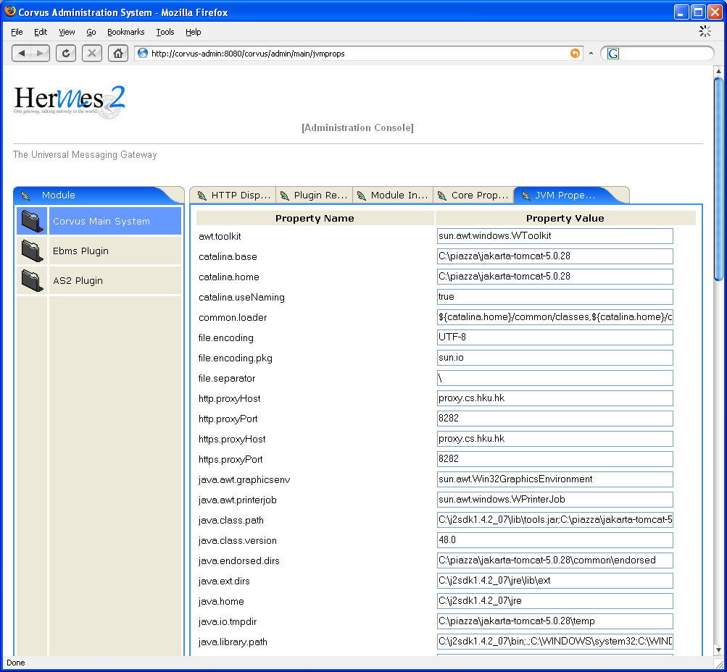

- The screen for showing and editing the JVM property values of Hermes 2 system

The user can enter new property values in the text boxes of the page. To commit the change, the users can click on the "Update" button. Upon clicking, a window (Figure 12) will be shown to prompt the users for confirmation.

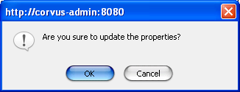

- Confirmation window for updating the JVM property values of Hermes 2 system

ebXML Messaging Services Plugin Administration
The ebXML Messaging Services plugin handles the messages send to and receive from the B2B partners using ebXML messaging services protocol. In the admin console, the users can query the history of the messages processed by the plugin. The users can also manage the partnership information about the B2B partners.
When the user clicks on the link of Ebms Plugin in the menu at left hand side, the administration console will show the pages for administration of the plugin in the content area at the right hand side.
There are two administration pages for the ebXML Messaging Services Plugin.

Message History
When the user clicks on the tab "Message H…" at the top part of the content area at the right hand side, the screen for querying message history will be shown (Figure 13).

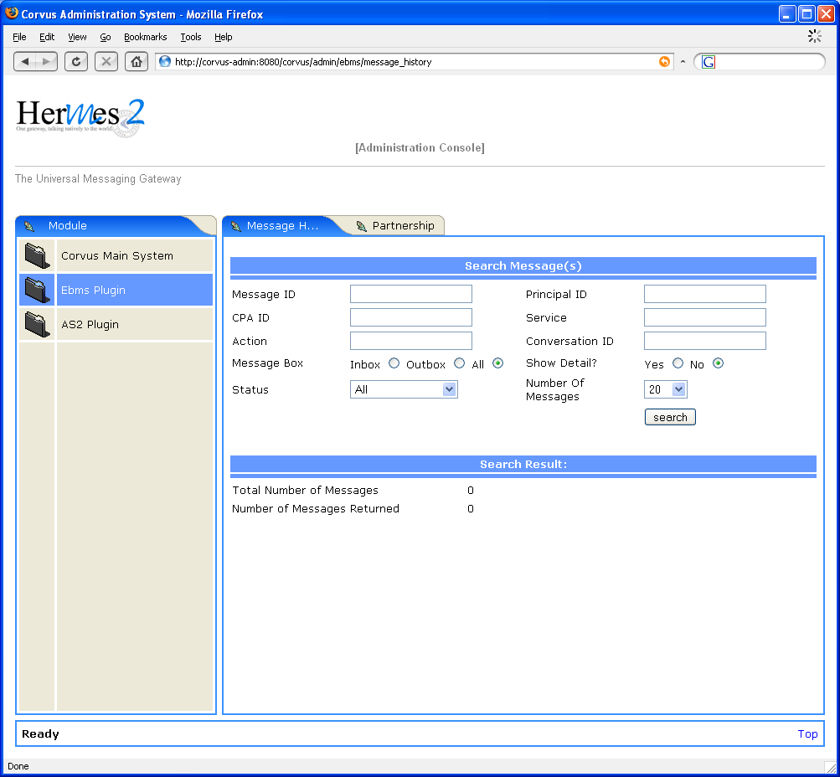
- The screen for querying the message status

In the right hand side, the user can enter one or more query parameters to narrow down the search result. In the case that the text box is left blank, the system will not filter the result on that parameter.
The user can also choose how many message to show in one page. The query will be trigger by clicking the "search" button. Then, the result will be shown at the lower part of the content area (Figure 14).

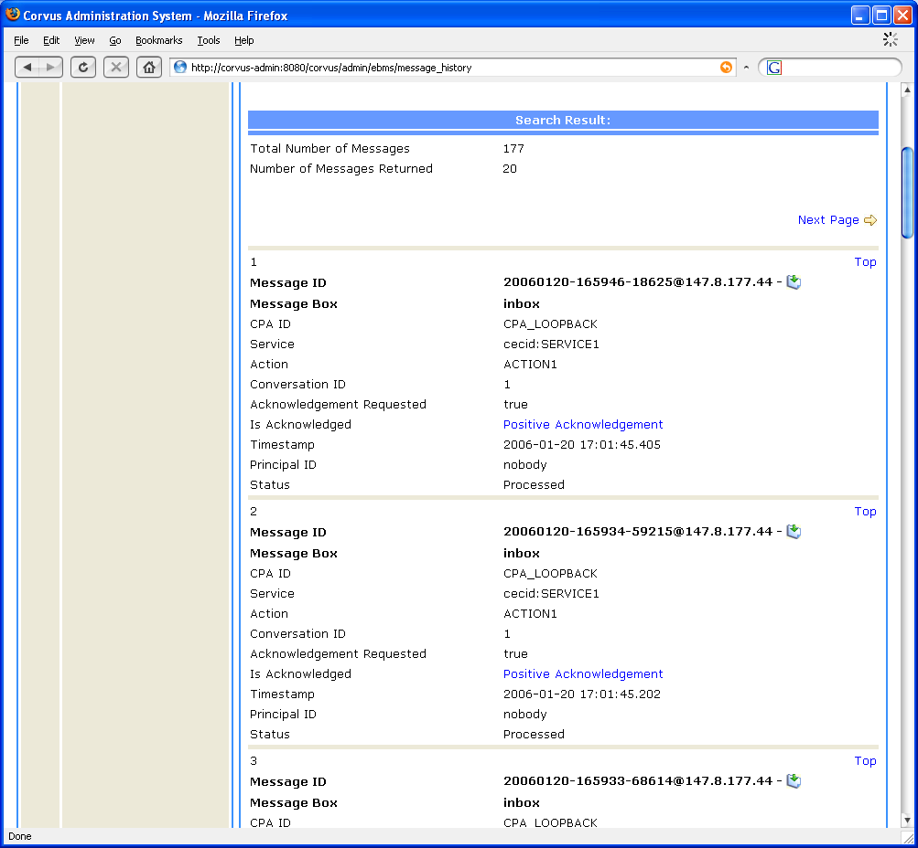

- The screen showing the query result of message status
In the result, the messages matching the query parameters are listed one by one. The user can click on link to see the acknowledgment message of a particular message (Figure 15).

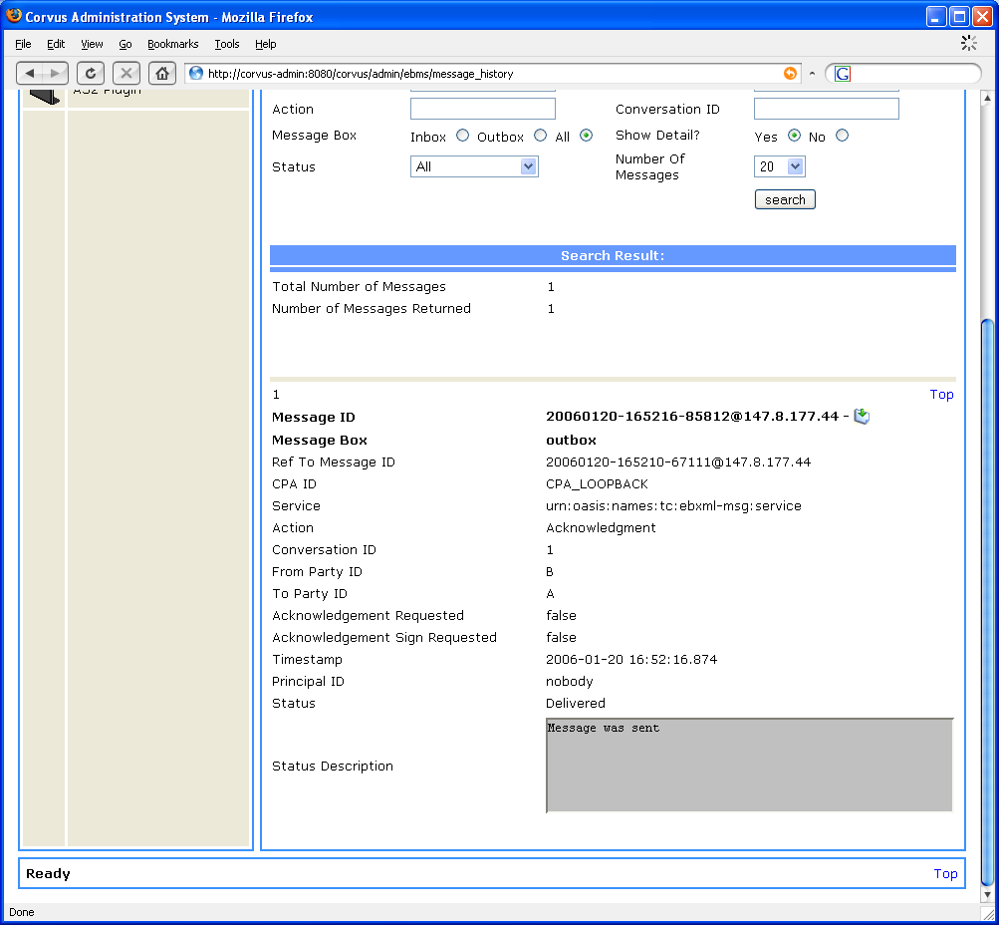

- The screen showing the acknowledgment of a particular message
The user can also click on the icon to download the body of each message (Figure 16).

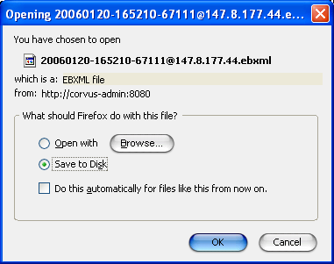

- The screen for downloading the message body

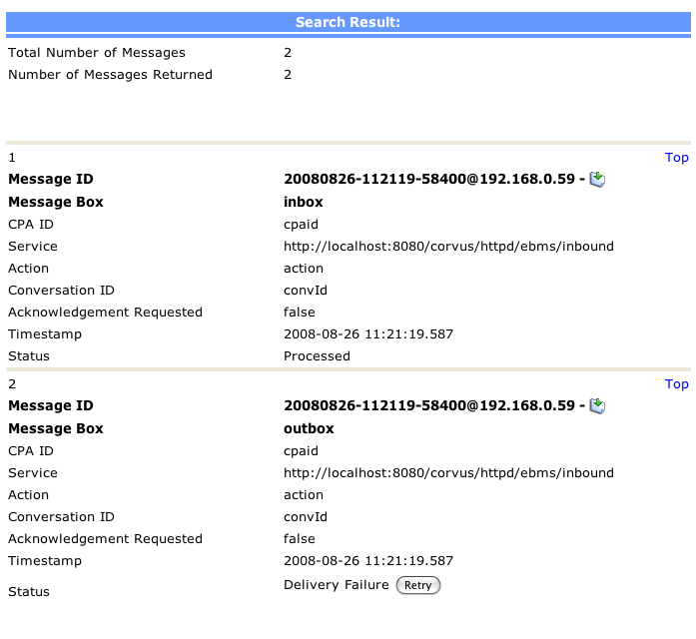
- The screen for showing an failed message delivery

User can click the button to re-send the message if the status of the message is shown Delivery Failure.
Be reminded, if the recipient has received this message already, the retry action would probably fail. It is because the record still persists in recipient’s database/repository. Hence, the Retry function would be the best solution if delivery failure was caused by connection problem.
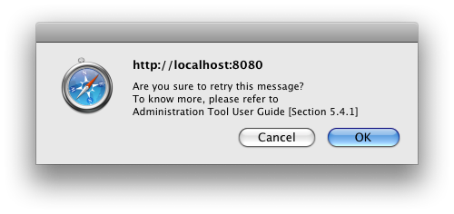
- The screen of Retry Confirmation Windows

Partnership
When the user clicks on the tab "Partnership" at the top part of the content area at the right hand side, the screen for managing partnership information will be shown (Figure 17).

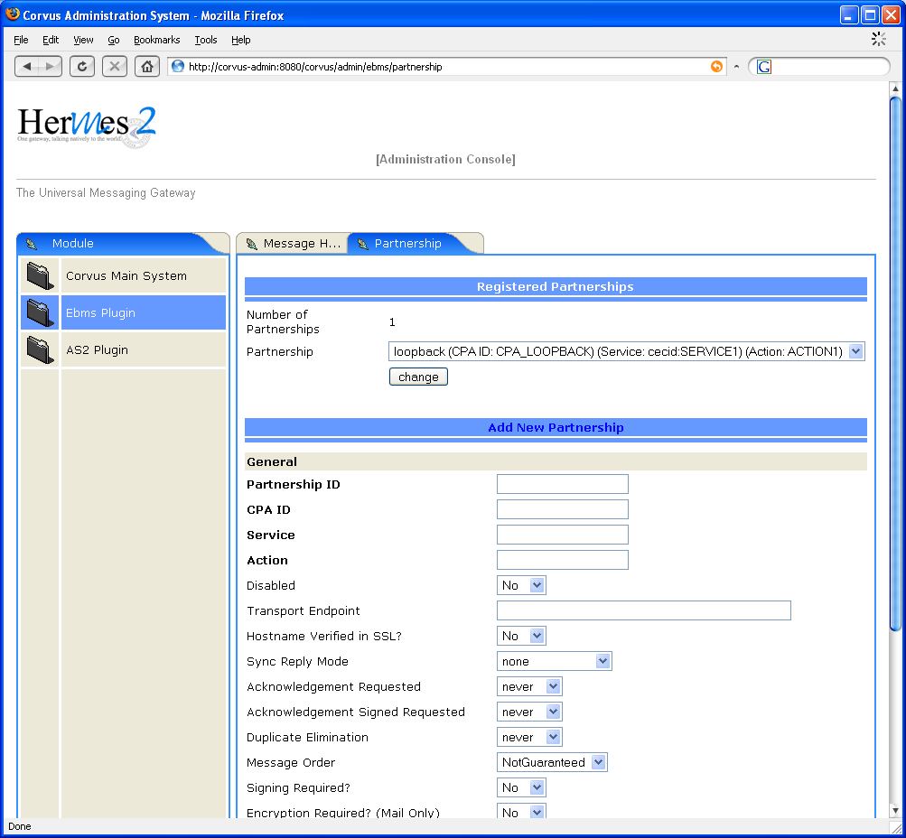

- The screen for managing the partnership information
There is a drop down list showing the registered partnerships in the system. To change an existing partnership, the users can select that partnership to be changed at the drop down list, and then click on the "change" button. Then the page will be loaded with that partnership for editing (Figure 18).

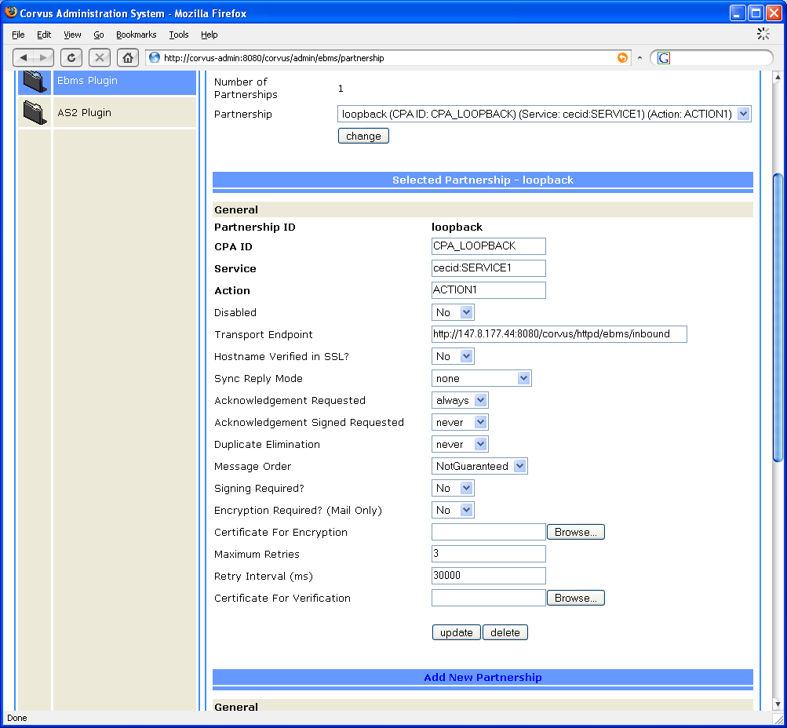
- The screen for editing existing partnership information
The users can update the partnership information. Then, they can click on the "update" button to commit the change. Upon clicking the button, a window (Figure 19) will be shown to prompt the user for confirmation.

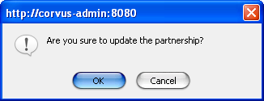
- Confirmation window to update the partnership
If the user has confirmed the changes, but there are some unacceptable values by the system. The system will show up a message at the bottom part of the window to inform the user (Figure 20).

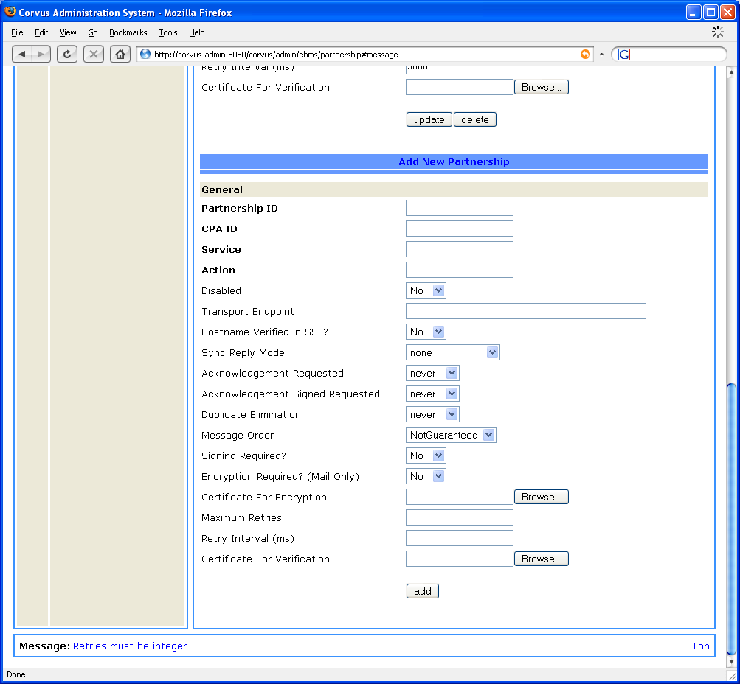
- The screen showing the system message when there is wrong information input when editing partnership information

The users can also click on the "delete" button to delete the partnership. Upon clicking the button, a window (Figure 21) will be shown to prompt the user for confirmation.

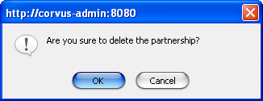

- Confirmation window to delete the partnership
At the lower part of the form, the users can find a section to add a new partnership (Figure 22).
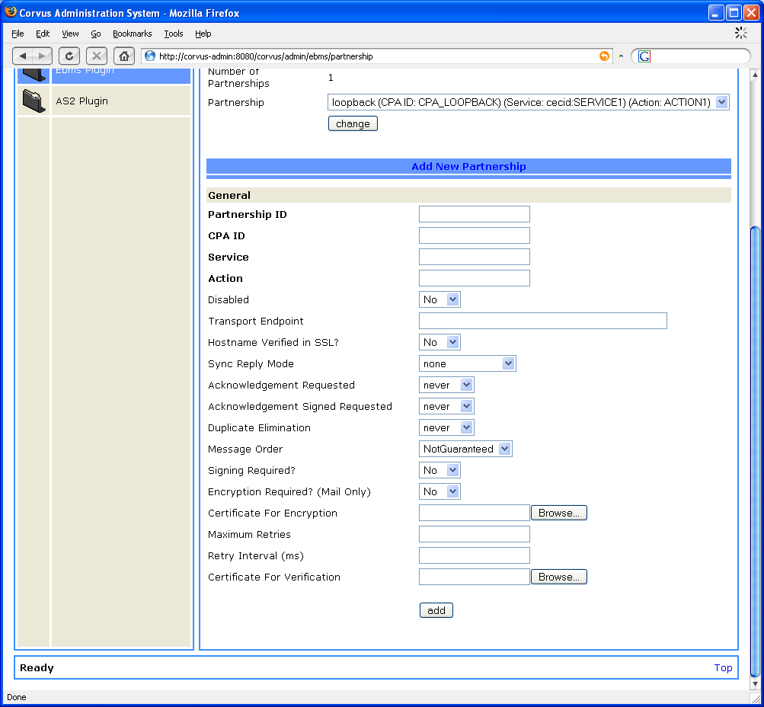
- The screen for adding new partnership information

The users can fill in the parameters, and then click the "add" button to commit the change. Upon clicking the button, a window (Figure 23) will be shown to prompt the user for confirmation.
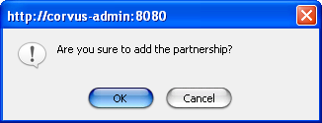
- Confirmation window to add the partnership

If the user has confirmed the action, but there are some unacceptable values by the system. The system will show up a message at the bottom part of the window to inform the user (Figure 24).

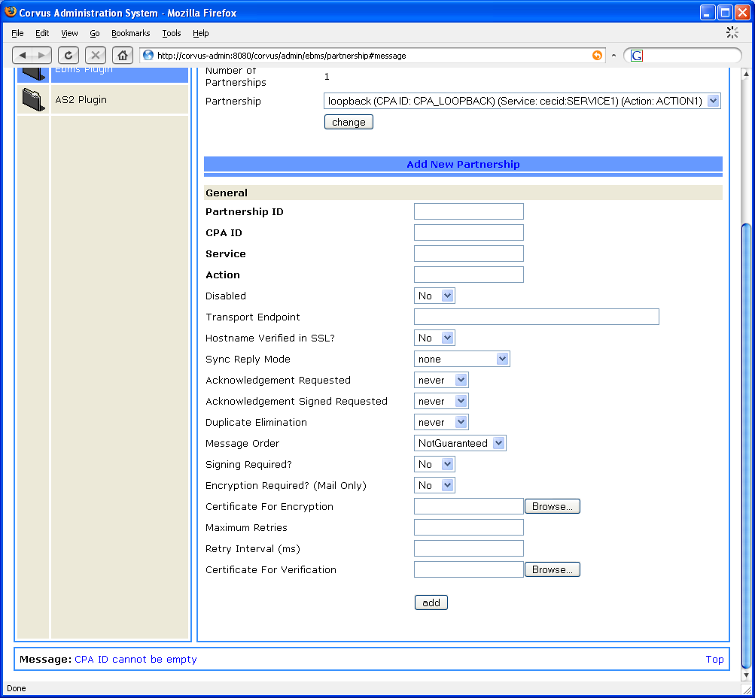
- The screen showing the system message when there is wrong information input when adding partnership information

AS2 Plugin Administration
The AS2 plugin handles the messages send to and receive from the B2B partners using AS2 protocol. In the admin console, the users can query the history of the messages processed by the plugin. The users can also manage the partnership information about the B2B partners.
When the user clicks on the link of AS2 Plugin in the menu at left hand side, the administration console will show the pages for administration of the plugin in the content area at the right hand side.
There are two administration pages for the AS2 Plugin.

Message History
When the user clicks on the tab "Message H…" at the top part of the content area at the right hand side, the screen for querying message history will be shown (Figure 25).
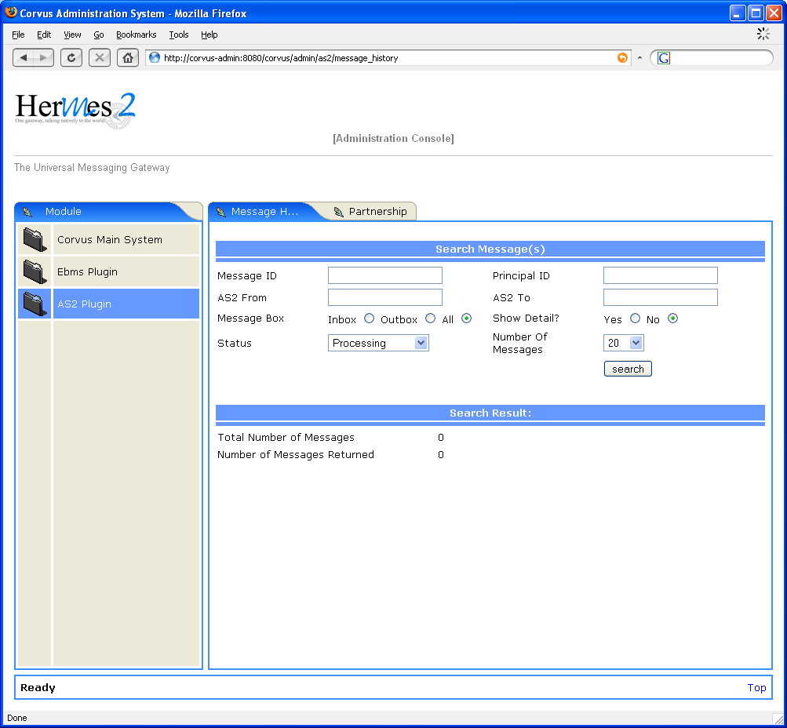
- The screen for querying the message status
In the right hand side, the user can enter one or more query parameters to narrow down the search result. In the case that the text box is left blank, the system will not filter the result on that parameter.
The user can also choose how many message to show in one page. The query will be trigger by clicking the "search" button. Then, the result will be shown at the lower part of the content area (Figure 26).

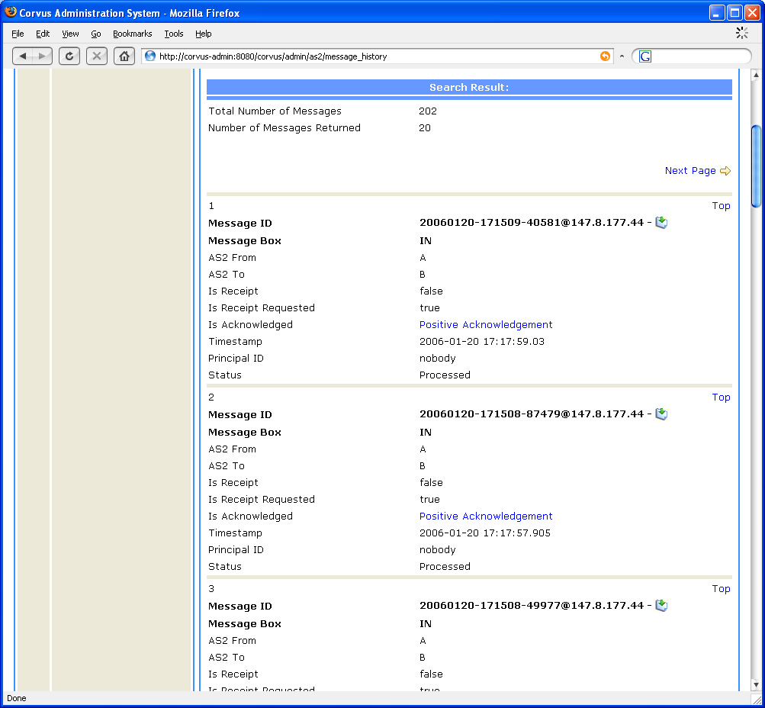
- The screen showing the query result of message status

In the result, the messages matching the query parameters are listed one by one. The user can click on link to see the acknowledgment message of a particular message (Figure 27).

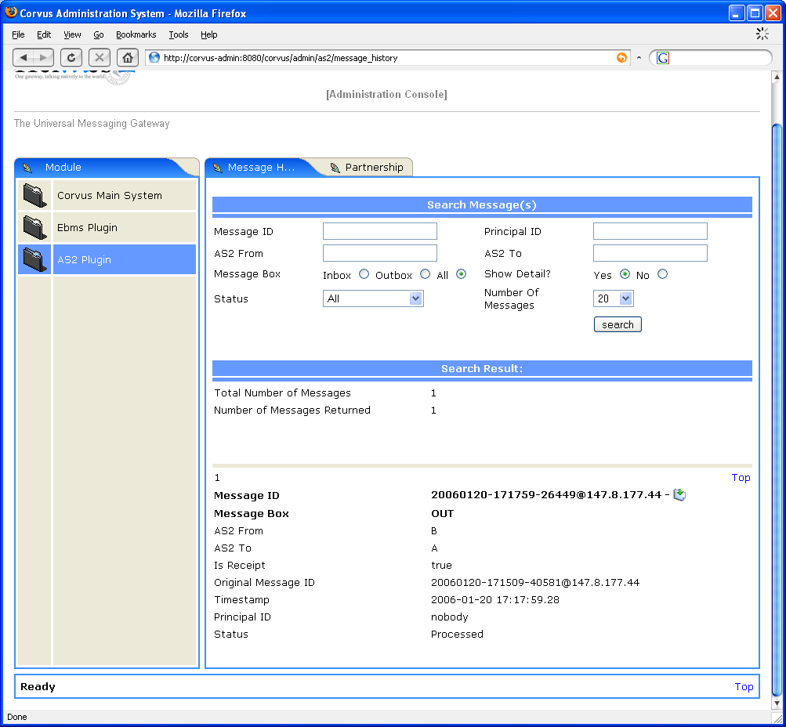
- The screen showing the acknowledgment of a particular message
The user can also click on the icon to download the body of each message (Figure 28).

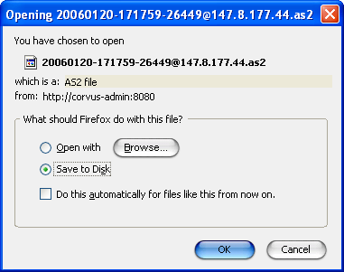
- The screen for downloading the message body

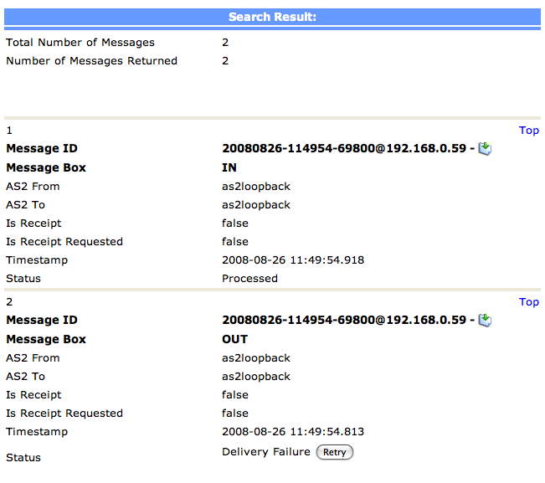
- The screen for showing an failed message delivery

User can click the button to re-send the message if the status of the message is shown Delivery Failure.
Be reminded, if the recipient has received this message already, the retry action would probably fail. It is because the record still persists in recipient’s database/repository. Hence, the Retry function would be the best solution if delivery failure was caused by connection problem.
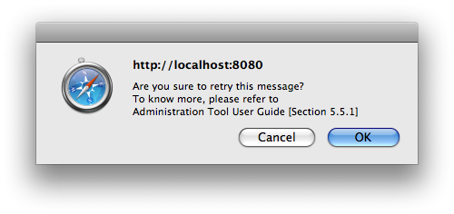
- The screen for Retry Confirmation Windows

Partnership
When the user clicks on the tab “Partnership” at the top part of the content area at the right hand side, the screen for managing partnership information will be shown (Figure 29).

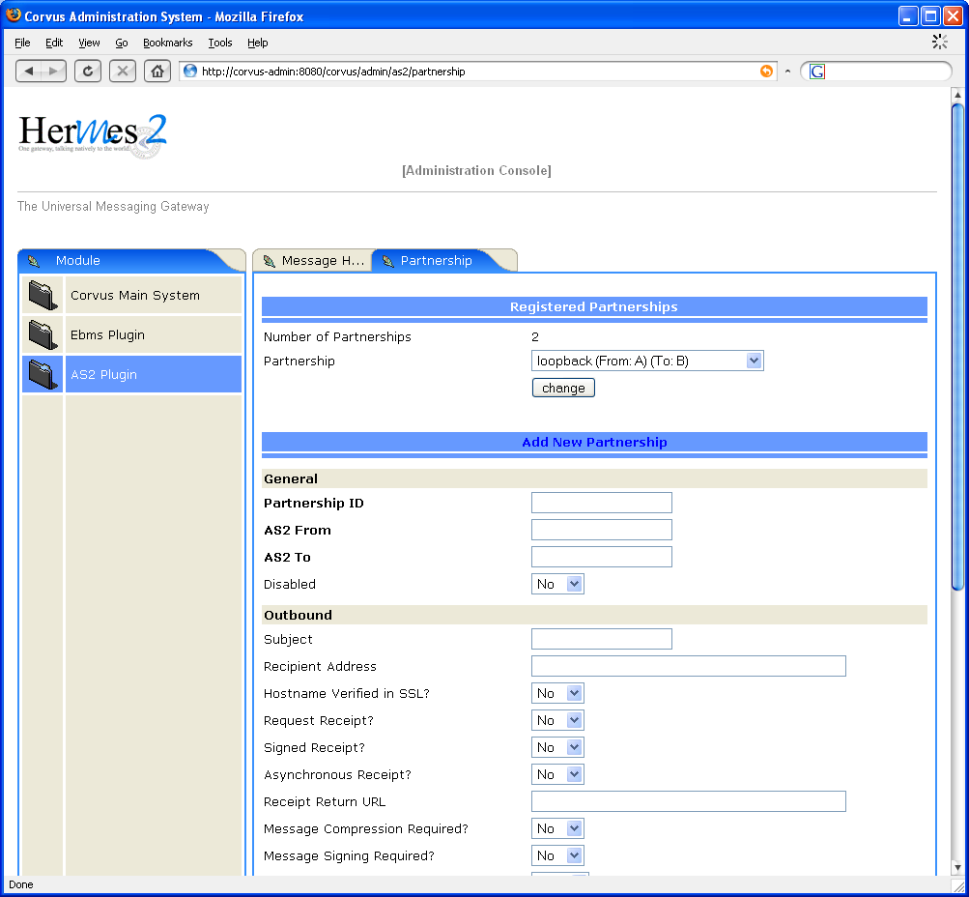
- The screen for managing the partnership information
There is a drop down list showing the registered partnerships in the system. To change an existing partnership, the users can select that partnership to be changed at the drop down list, and then click on the "change" button. Then the page will be loaded with that partnership for editing (Figure 30).

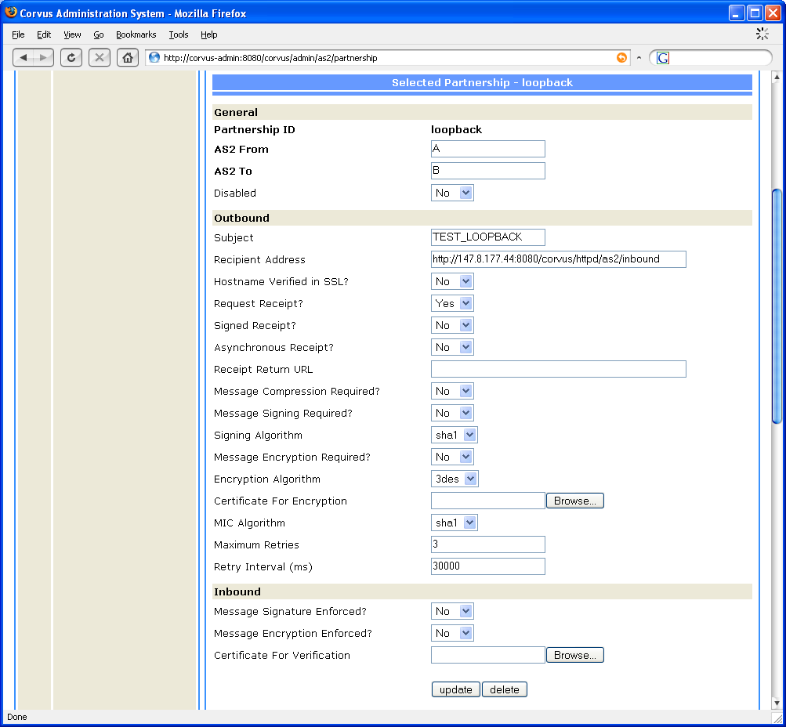
- The screen for editing existing partnership information

The users can update the partnership information. Then, they can click on the "update" button to commit the change. Upon clicking the button, a window (Figure 31) will be shown to prompt the user for confirmation.

- Confirmation window to update the partnership

If the user has confirmed the changes, but there are some unacceptable values by the system. The system will show up a message at the bottom part of the window to inform the user (Figure 32).

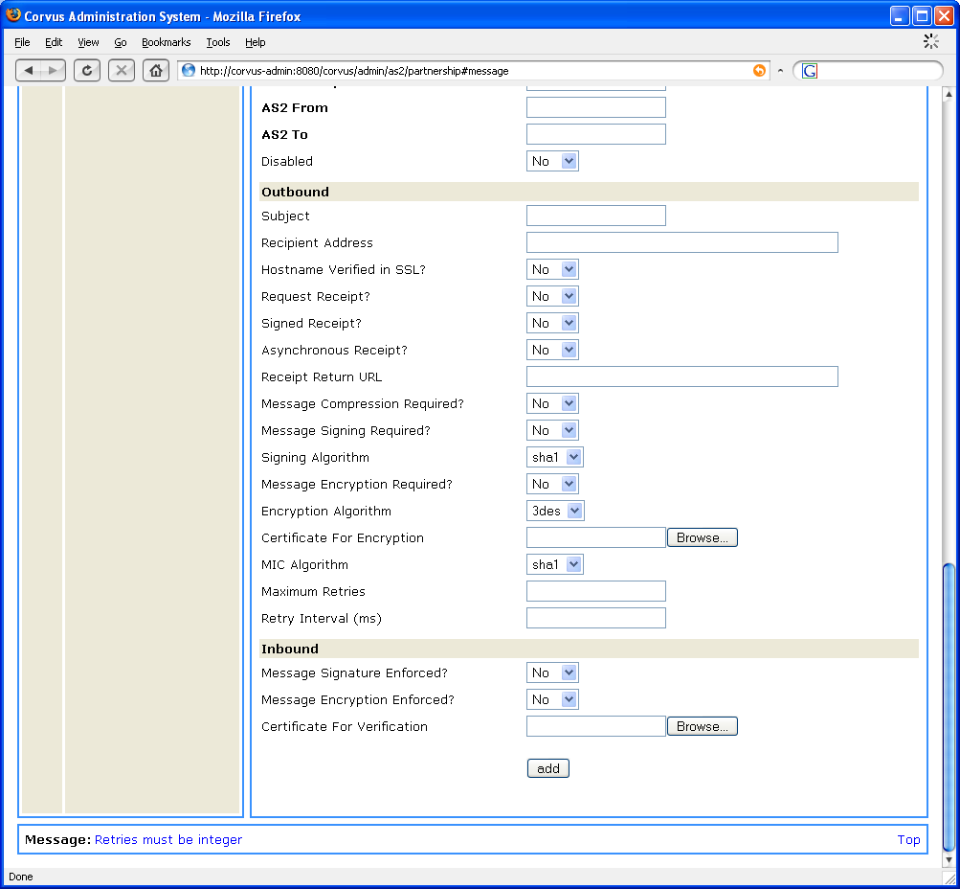
- The screen showing the system message when there is wrong information input when editing partnership information

The users can also click on the "delete" button to delete the partnership. Upon clicking the button, a window (Figure 33) will be shown to prompt the user for confirmation.

- Confirmation window to delete the partnership

At the lower part of the form, the users can find a section to add a new partnership (Figure 34).

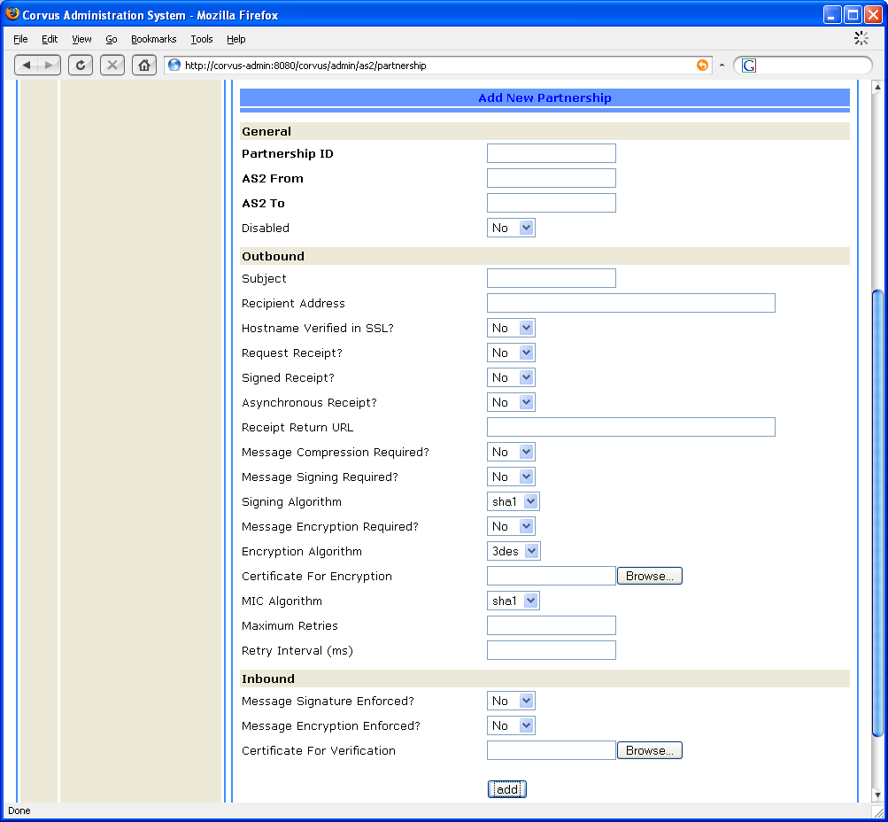
- The screen for adding new partnership information

The users can fill in the parameters, and then click the "add" button to commit the change. Upon clicking the button, a window (Figure 35) will be shown to prompt the user for confirmation.
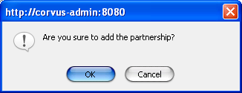
- Confirmation window to add the partnership

If the user has confirmed the action, but there are some unacceptable values by the system. The system will show up a message at the bottom part of the window to inform the user (Figure 36).
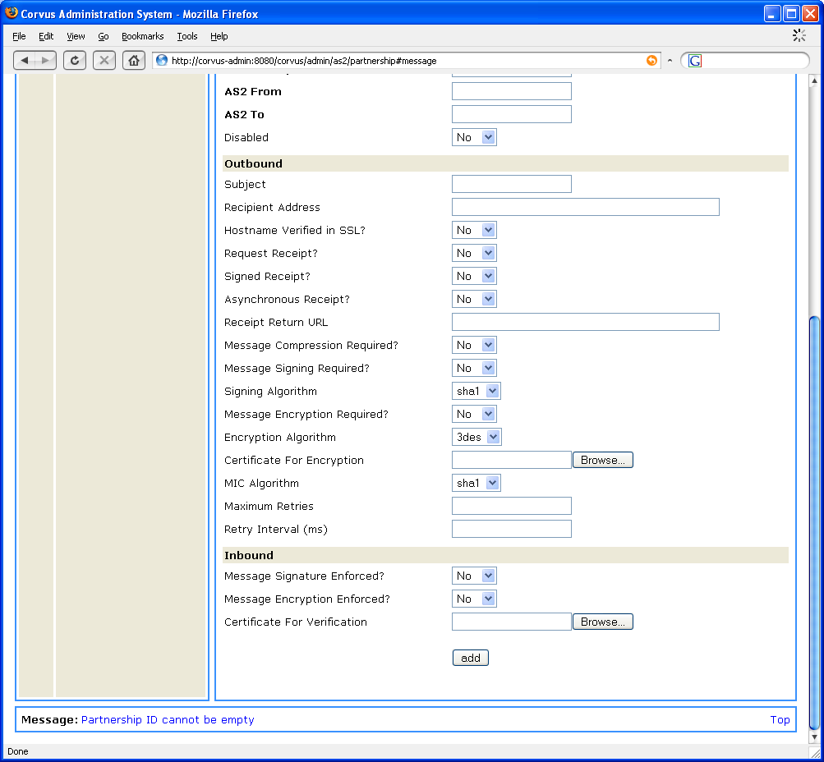
- The screen showing the system message when there is wrong information input when adding partnership information

References
- Hermes 2 Application Development Guide
- Hermes 2 Installation Guide
- OASIS ebXML Message Service Specification 2.0
www.oasis-open.org/committees/ebxml-msg/documents/ebMS_v2_0.pdf
- MIME-based Secure Peer-to-Peer Business Data Interchange over the Internet Using HTTP AS2 (draft-ietf-ediint-as2-17.txt)
http://www.ietf.org/rfc/rfc4130.txt

